**To:** Jie Yang  
**From:** Team 5, EE-286 Section 1Mason Gerace, Felecia Hildebran, Joshua Pollock, Taylor Yee  
**Date:**  November 1, 2018 **RE:** Project 3 - Design Selection

**Assignment:**

The teams will submit a memo outlining their design choice for this project. This memo is due Thursday, November 8. The memo will contain the following:

1. A paragraph building a backstory for the project – who is the customer and what does he want?
2. A formal problem statement
3. A decision matrix demonstrating how this particular project was chosen
4. A Gantt chart for the project showing all milestones beginning on November 1. Also include a WBS showing task assignments as you did in the last project.

In addition, teams who provide adequate design documentation for the project (see the Project 3 Intro memo or the Update 1 memo soon to follow) may have their kits issued to them.

**Introduction:**

The team is submitting a memo detailing the choice we have made for the project. To accomplish this we have included a backstory for the project, a formal problem statement, a decision matrix, a WBS chart, and lastly a Gantt chart. We detail all the major milestones and what we are doing throughout the whole project in the Gantt and WBS charts, while also depicting how we came to our final choice in the decision matrix.

**Backstory:**

Elon Musk has been looking for concepts for a autonomous rover to roam mars. However, every rover he has looked at thus far has ran into objects and not met his expectations. Elon Musk would like a unique rover that is easy to build and program. He would also like a rover that is creative, cost effective, and simple.

**Problem Statement:**

The team must create a rover-like toy using the Arduino, two motors, and three sensors. Additionally, the toy must make noise and include flashing lights.

**Decision Matrix:**

Parameters for decision matrix:

* Buildability
* Programmability
* Creativity
* Cost
* Simplicity

Pairwise Comparison:

|  |  |  |  |  |  |  |  |
| --- | --- | --- | --- | --- | --- | --- | --- |
| **Criteria** | **Buildability** | **Programmability** | **Creativity** | **Cost** | **Simplicity** | **Geometric Mean** | **Weight** |
| **Buildability** | 1 | 1 | 3 | 3 | 5 | 2.14113 | 0.34417 |
| **Programmability** | 1 | 1 | 3 | 3 | 5 | 2.14113 | 0.34417 |
| **Creativity** | 1/3 | 1/3 | 1 | 3 | 3 | 1.00000 | 0.16074 |
| **Cost** | 1/3 | 1/3 | 1/3 | 1 | 1 | 0.51728 | 0.08315 |
| **Simplicity** | 1/5 | 1/5 | 1/3 | 1 | 1 | 0.42168 | 0.06778 |

Here is the pairwise comparison table. We used a 1,3,5 scale to rank the criteria based on the importance to the project. Buildability and programmability ranked the highest weighted categories while cost and simplicity had small weights. Creativity fell in the middle of all the criteria.

Unweighted Decision Matrix:

|  |  |  |  |  |  |
| --- | --- | --- | --- | --- | --- |
| **Criteria** | **Launcher** | **Digital Metronome/8-bit Music Player** | **Drone Simulator** | **Clock** | **Autonomous Rover** |
| **Buildability** | 4 | 1 | 2 | 5 | **3** |
| **Programmability** | 1 | 2 | 4 | 3 | **5** |
| **Creativity** | 1 | 5 | 3 | 2 | **4** |
| **Cost** | 5 | 1 | 2 | 4 | **3** |
| **Simplicity** | 4 | 1 | 2 | 5 | **3** |
| **Total** | 15 | 10 | 13 | 19 | **18** |

Above is the decision matrix before taking the weight into account. We can see from this table that without the weighting of the pairwise comparison, the clock would be the winning idea.

Weighted Decision Matrix:

|  |  |  |  |  |  |  |
| --- | --- | --- | --- | --- | --- | --- |
| **Criteria** | **Weight** | **Launcher** | **Digital Metronome/8-bit Music Player** | **Drone Simulator** | **Clock** | **Autonomous Rover** |
| **Buildability** | 0.34 | 1.38 | 0.34 | 0.69 | 1.72 | **1.03** |
| **Programmability** | 0.34 | 0.34 | 0.69 | 1.38 | 1.03 | **1.72** |
| **Creativity** | 0.16 | 0.16 | 0.80 | 0.48 | 0.32 | **0.64** |
| **Cost** | 0.08 | 0.42 | 0.08 | 0.17 | 0.33 | **0.25** |
| **Simplicity** | 0.07 | 0.27 | 0.07 | 0.14 | 0.34 | **0.20** |
| **Total** | 1.00 | 2.57 | 1.99 | 2.85 | 3.75 | **3.85** |

Here is the final decision matrix with the weight of each criteria taken into consideration. We can see from this matrix that the clock and autonomous rover were very close to one another. However once we took the weight of each criteria into consideration, out group has come to the conclusion of using the autonomous rover.

**Gantt Chart:**

Below is our Gantt chart for this project which depicts a tentative timeline of our project.

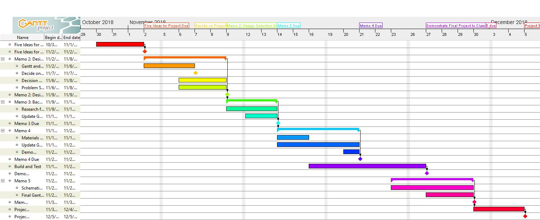

**WBS Chart:**

Below is our Work Breakdown Structure chart which depicts each of the tasks to be completed and who is expected to complete each one.

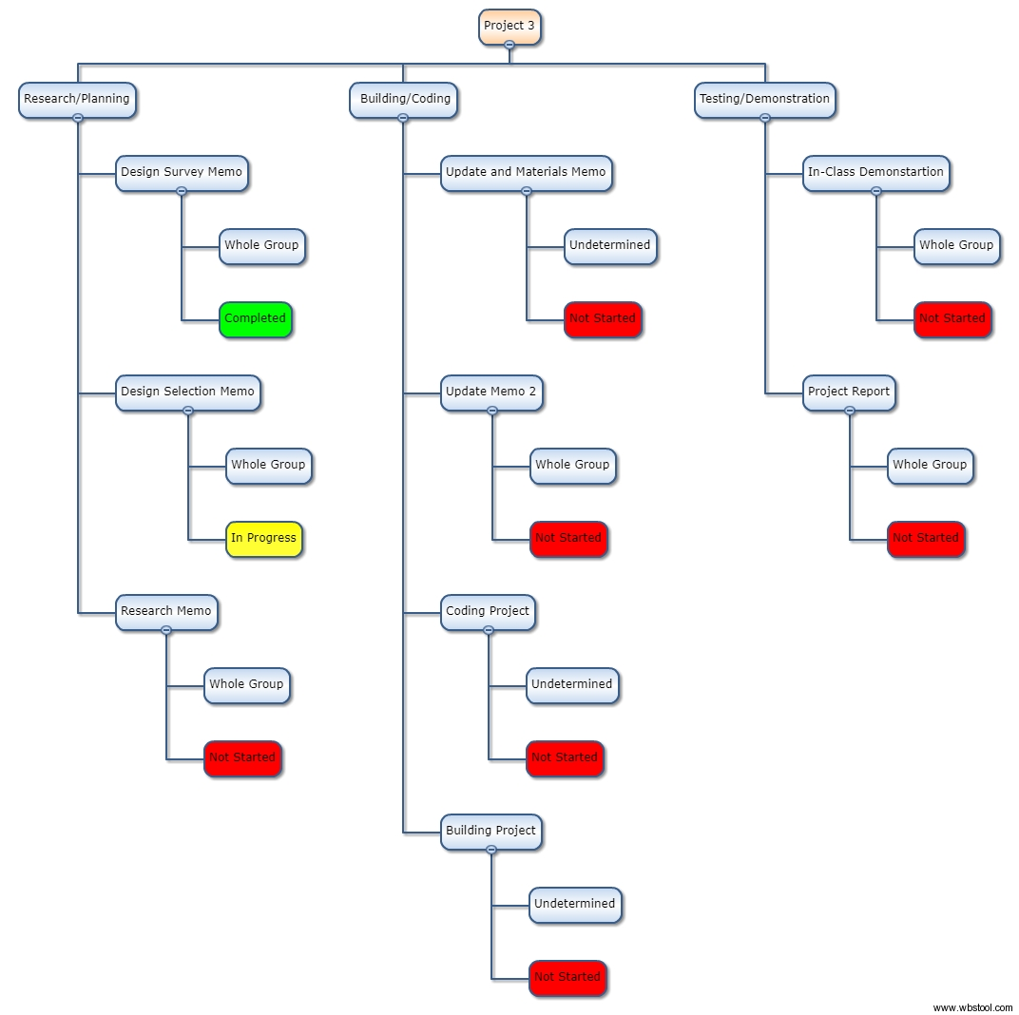

**Conclusion:**

In this memo, a backstory and problem statement were presented to give more information for our project. Additionally, WBS and Gantt charts were created to detail tentative assignments, tasks, and progress for our team. Finally, a pairwise and decision matrix were created for justification as to why we chose the autonomous rover for our project. Moving forward, this memo will allow us to begin prototyping our design and make adjustments as needed, while giving us a backup plan in the event that our project becomes unable to complete in the timeframe given.

**Attachments:** none